**Week 3 Assignment**

Shlok Manandhar

Westcliff University

PRG 402: Mobile Programming Applications

Prof. Khanal

Mar 16, 2025

Code:

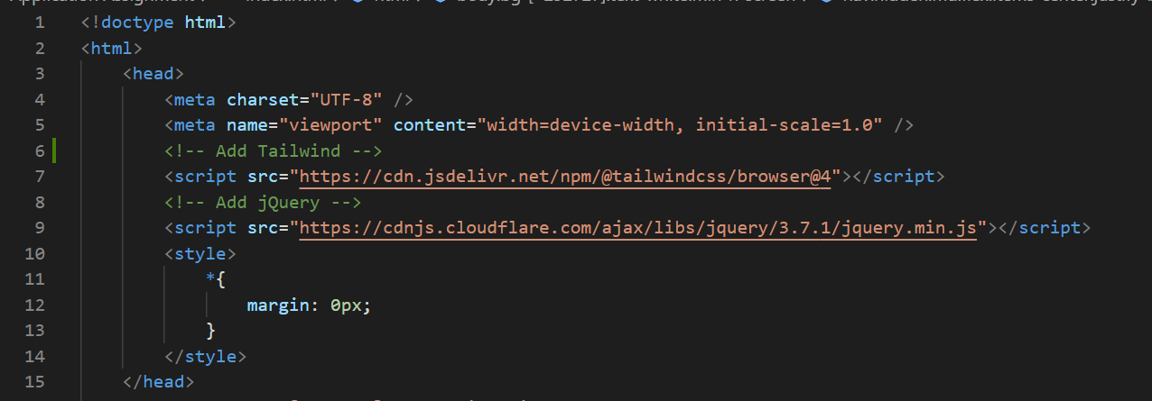

Importing Tailwind CSS and jQuery on the head section

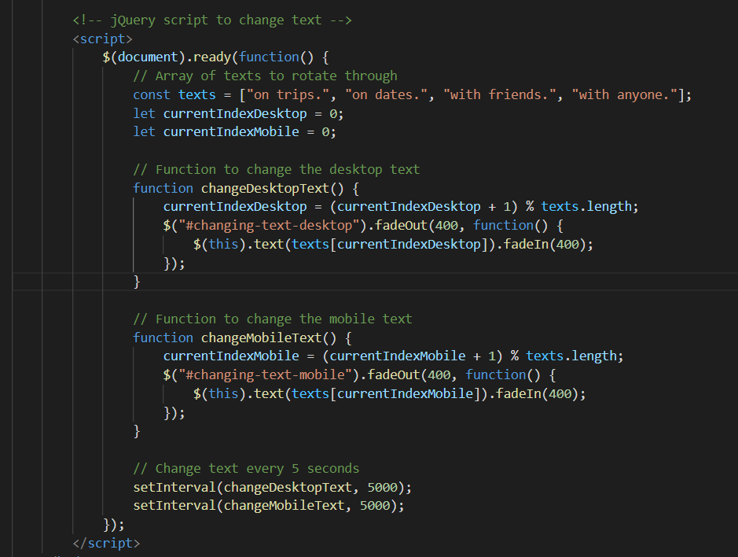

Using jQuery in my code, which changes, a certain text after every 5 seconds.

How it looks